RAJALAKSHMI ENGINEERING COLLEGE
RAJALAKSHMI NAGAR, THANDALAM – 602 105


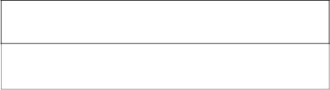

AI19P71

-

DATA

VISUALIZATION

USING

PYTHON

Laboratory

Record

NoteBook

Name : . . . . . . . . . . . . . . . . . Varshini S . . . . . . . . . . . . . . . . . . . . . . . . . . .
Year / Branch / Section : IV- AIML
Register No. : . . . . . . . ..2116221501165 . . . . . . . . . . . . . . . . . . . . . . . . . . . . .
College Roll No. : . . . . . . .221501165 . . . . . . . . . . . . . . . . . . . . . . . . . . . . . . .
Semester : 07
Academic Year : 2025-2026

RAJALAKSHMI ENGINEERING COLLEGE
RAJALAKSHMI NAGAR, THANDALAM – 602 105

BONAFIDE CERTIFICATE
Name : . . . . . . . . . . . Varshini S . . . . . . . . . . . . . . . . . . . . . . . . . . . . . . . . . . . . . . .
Academic Year : . . . . 2025-2026. . . . . . Semester : 07 Branch : AIML
Register No. 
2116221501165

Certified that this is the bonafide record of work done by the above student in the
AI19P71 - DATA VISUALIZATION USING PYTHON LABORATORY
during the year 2025 - 2026.
Signature of Faculty in-charge
Submitted for the Practical Examination held on . . . . . . . . . . . . . . . . . .
Internal Examiner External Examiner

Ex.No. 1 (a) | BASIC NUMPY ARRAY OPERATIONS
Date : | BASIC NUMPY ARRAY OPERATIONS
AIM:
To understand the basics of NumPy arrays including creation, attributes, slicing and indexing.
ALGORITHM:
Step 1: Start.
Step 2: Initialize months and sales_revenue lists.
Step 3: Convert sales_revenue to NumPy array → revenue_array.
Step 4: Retrieve array attributes: shape, size, dtype.
Step 5: Slice revenue_array for January–June → first_half_revenue.
Step 6: Index May’s revenue → revenue_array[4].
Step 7: Calculate total revenue → revenue_array.sum().
Step 8: Find index of max revenue → revenue_array.argmax(); get corresponding month.
Step 9: Display results (attributes, first half, May, total, highest month).
Step 10: Stop.

SOURCE CODE:
import numpy as np

months = ['January', 'February', 'March', 'April', 'May', 'June',’ 'July', 'August', 'September',
'October', 'November', 'December'] sales_revenue = [12000, 15000, 17000, 13000, 16000, 18000, 20000, 19000, 17500, 16000,
15000, 16500] sales_array = np.array(sales_revenue) print("Shape:", sales_array.shape) print("Size:", sales_array.size) print("Data type:", sales_array.dtype) print("First half of the year sales revenue:", sales_array[:6]) print("Sales revenue for May:", sales_array[4])
total_sales = np.sum(sales_array) print("Total sales revenue for the year:", total_sales) max_index = np.argmax(sales_array) #
gives index of max value print("Month with highest sales revenue:", months[max_index])

OUTPUT:
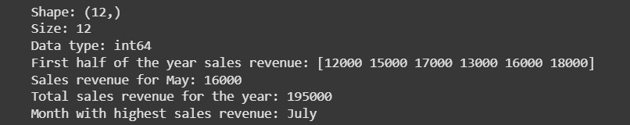

RESULT:
Thus, the Python program to analyze the company’s monthly sales revenue using NumPy by retrieving attributes, slicing data, indexing values, computing total revenue and identifying the highest sales month has been executed successfully.

Ex.No. 1 (b) | AGGREGATE FUNCTIONS
Date: | AGGREGATE FUNCTIONS

AIM:
To use aggregate functions in NumPy for summarizing and analyzing data.
ALGORITHM:
Step 1: Start.
Step 2: Initialize the dictionary returns_data with returns for Portfolio A, B, and C.
Step 3: Convert each portfolio’s return list into a NumPy array — A_array, B_array and C_array.
Step 4: Calculate the total return for each portfolio using the sum() function.
Step 5: Compute the mean monthly return for each portfolio using the mean() function.
Step 6: Identify the portfolio with the highest mean return using argmax().
Step 7: Combine all portfolio arrays and compute the overall average return using mean() on the combined data.
Step 8: Calculate the variance and standard deviation for each portfolio using var() and std() respectively to assess investment risk.
Step 9: Display all computed statistics.
Step 10: Stop.

SOURCE CODE:
import numpy as np
returns_data = { 'portfolio_A': [0.05, 0.02, 0.04, 0.03, 0.06, 0.01],
'portfolio_B': [0.04, 0.03, 0.05, 0.02, 0.01, 0.04], 'portfolio_C': [0.03, 0.01, 0.02, 0.03, 0.04, 0.05]} portfolio_A = np.array(returns_data['portfolio_A']) portfolio_B = np.array(returns_data['portfolio_B']) portfolio_C = np.array(returns_data['portfolio_C']) total_A = np.sum(portfolio_A) total_B = np.sum(portfolio_B) total_C = np.sum(portfolio_C)
mean_A = np.mean(portfolio_A) mean_B = np.mean(portfolio_B) mean_C = np.mean(portfolio_C)
mean_returns = {'portfolio_A': mean_A, 'portfolio_B': mean_B, 'portfolio_C': mean_C} best_portfolio = max(mean_returns, key=mean_returns.get) all_returns = np.concatenate([portfolio_A, portfolio_B, portfolio_C]) overall_avg = np.mean(all_returns)
var_A, std_A = np.var(portfolio_A), np.std(portfolio_A) var_B, std_B = np.var(portfolio_B), np.std(portfolio_B) var_C, std_C = np.var(portfolio_C), np.std(portfolio_C) print("Total returns:", total_A, total_B, total_C) print("Mean monthly returns:", mean_A, mean_B, mean_C) print("Portfolio with highest mean return:", best_portfolio) print("Overall average return across all portfolios:", overall_avg) print("Variance:", var_A, var_B, var_C) print("Standard deviation:", std_A, std_B, std_C)

OUTPUT:

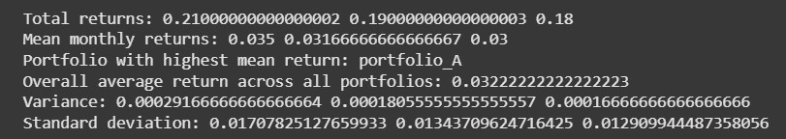

RESULT:
Thus the Python program to analyze and summarize the investment portfolios’ monthly returns using NumPy aggregate functions by computing total returns, mean returns, overall averages, variances and standard deviations has been executed successfully.
Ex.No. 1 (c) | SPLITTING AND AGGREGATION
Date: | SPLITTING AND AGGREGATION
AIM:
To practice slicing, indexing, splitting, and aggregating Numpy arrays.
ALGORITHM:
Step 1: Start.
Step 2: Initialize the rainfall dataset:
rainfall_data = [120, 85, 90, 110, 95, 100, 105, 85, 115, 130, 125, 140] Step 3: Convert the list into a NumPy array → rain_array.
Step 4: Slice rain_array[0:3] to obtain rainfall for the first quarter (Jan–Mar).
Step 5: Index rain_array[6] to get the rainfall for July.
Step 6: Split the array into four equal quarters using np.split(rain_array, 4).
Step 7: For each quarter:
- Print the rainfall data.
- Calculate total rainfall using sum().
- Identify the month with highest rainfall using max().
Step 8: Display all computed quarterly totals and highest rainfall values.
Step 9: Stop.

SOURCE CODE:
import numpy as np rainfall_data = [120, 85, 90, 110, 95, 100, 105, 85, 115, 130, 125, 140] rainfall_array = np.array(rainfall_data) first_quarter = rainfall_array[:3] print("First Quarter Rainfall Data:", first_quarter) print("Rainfall for July:", rainfall_array[6]) quarters = np.split(rainfall_array, 4) print("First Quarter Rainfall Data:", quarters[0])
print("Second Quarter Rainfall Data:", quarters[1]) print("Third Quarter Rainfall Data:", quarters[2]) print("Fourth Quarter Rainfall Data:", quarters[3]) for i, q in enumerate(quarters, start=1):
total = np.sum(q) max_index = np.argmax(q) + 1 # +1 for month number in that quarter max_value = q[max_index - 1] print(f"Total Rainfall for Quarter {i}: {total}") print(f"Month with highest rainfall in Quarter {i}: Month {max_index} with {max_value}")

OUTPUT:

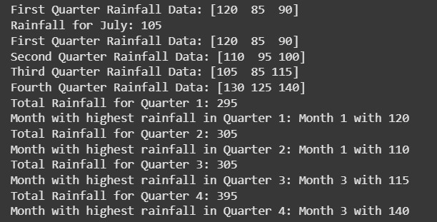

RESULT:
Thus, the Python program to analyze monthly rainfall data using NumPy by performing slicing, indexing, splitting and aggregation to determine quarterly totals and the month with the highest rainfall has been executed successfully.

Ex.No. 2 (a) | ANALYZING ACADEMIC PERFORMANCE
Date : | ANALYZING ACADEMIC PERFORMANCE
AIM:
To assess student performance trends across subjects while managing missing values, duplicates, and normalization using NumPy operations.
ALGORITHM:
Step 1: Start.
Step 2: Initialize the dataset with roll numbers and subject scores.
Step 3: Convert the list into a NumPy array.
Step 4: Identify missing values and duplicate records.
Step 5: Replace missing values with the median of each subject.
Step 6: Remove duplicate records, keeping the first occurrence.
Step 7: Apply Min–Max normalization to subject scores (excluding roll numbers).
Step 8: Calculate mean, median, and standard deviation for each subject.
Step 9: Identify the subject with the highest variability.
Step 10: Stop.

SOURCE CODE:
import numpy as np import pandas as pd

student_data = [(101, 45, 78, None),(102, 65, 56, 77),
(103, 95, 85, 92), (102, 65, 56, 77),
(104, 45, None, 88), (101, 45, 78, None)]
student_df = pd.DataFrame(student_data, columns=['Roll_Number', 'Mathematics', 'Science',
'English']) missing_values = student_df.isnull().sum() duplicate_entries = student_df.duplicated(subset=['Roll_Number'], keep=False) print("Missing values per subject:\n", missing_values)
print("\nDuplicate entries based on Roll Number:\n", student_df[duplicate_entries])
for col in ['Mathematics', 'Science', 'English']:
student_df[col].fillna(student_df[col].median(), inplace=True) student_df_cleaned = student_df.drop_duplicates(subset=['Roll_Number'], keep='first') print("\nCleaned DataFrame:\n", student_df_cleaned) scores_df = student_df_cleaned[['Mathematics', 'Science', 'English']].astype(float) student_df_normalized = (scores_df - scores_df.min()) / (scores_df.max() - scores_df.min()) normalized_mean = student_df_normalized.mean() normalized_median = student_df_normalized.median() normalized_std = student_df_normalized.std() print("\nNormalized Mean:\n", normalized_mean) print("\nNormalized Median:\n", normalized_median) print("\nNormalized Standard Deviation:\n", normalized_std) subject_highest_variability = normalized_std.idxmax() print(f"\nSubject with the highest variability: {subject_highest_variability}")

OUTPUT:

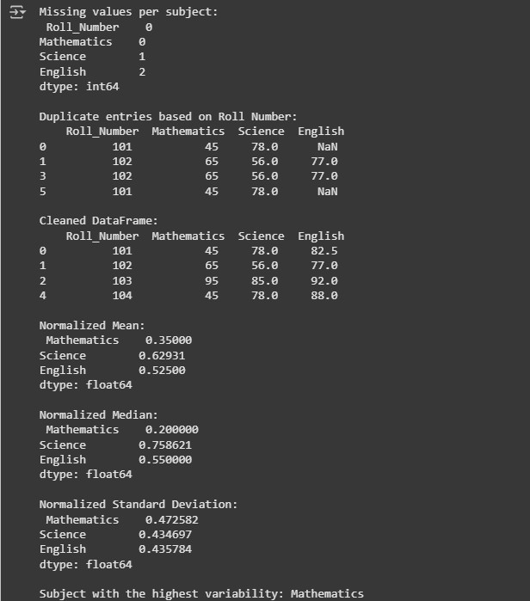

RESULT:
Thus, the Python program to clean, normalize, and analyze student academic performance data using NumPy has been executed successfully.

Ex.No. 2 (b) | ANALYZING HEALTHCARE SERVICE EFFICIENCY
Date : | ANALYZING HEALTHCARE SERVICE EFFICIENCY
AIM:
To evaluate departmental performance by handling missing data, duplicates, and performing normalization and statistical analysis using NumPy.
ALGORITHM:
Step 1: Start.
Step 2: Initialize the dataset with department IDs and performance metrics.
Step 3: Convert the list into a NumPy array.
Step 4: Identify missing values and duplicate department records.
Step 5: Replace missing values with the median of each metric.
Step 6: Remove duplicate records, keeping the first occurrence of each department.
Step 7: Apply Min–Max normalization to performance scores (excluding IDs).
Step 8: Calculate mean, median, and standard deviation for each metric.
Step 9: Identify the metric with the highest variability in scores.
Step 10: Stop.

SOURCE CODE:
import numpy as np

data = [
(701, 90, 95, None),
(702, 88, 90, 85),
(703, 92, None, 80),
(702, 88, 90, 85),
(704, 85, None, 78),
(701, 90, 95, None)
]
arr = np.array(data, dtype=object) print("Original Data:\n", arr) missing_counts = np.sum(arr[:, 1:] == None, axis=0) print("\nMissing values per metric (Satisfaction, Success Rate, Wait Time):", missing_counts)
_, unique_idx = np.unique(arr[:, 0], return_index=True) duplicates = np.setdiff1d(np.arange(len(arr)), unique_idx) print("\nDuplicate records:\n", arr[duplicates]) for col in range(1, arr.shape[1]):
values = arr[:, col] median_val = np.median([v for v in values if v is not None]) arr[:, col] = [median_val if v is None else v for v in values] arr = arr[np.sort(unique_idx)] print("\nCleaned Data (missing handled, duplicates removed):\n", arr) scores = arr[:, 1:].astype(float) min_vals = scores.min(axis=0) max_vals = scores.max(axis=0) normalized_scores = (scores - min_vals) / (max_vals - min_vals) print("\nNormalized Scores:\n", normalized_scores) means = normalized_scores.mean(axis=0) medians = np.median(normalized_scores, axis=0) std_devs = normalized_scores.std(axis=0) metrics = ["Patient Satisfaction", "Treatment Success Rate", "Wait Time"] max_var_metric = metrics[np.argmax(std_devs)] print("\nStatistical Summary (Normalized Metrics)")
print("----------------------------------------------------") print("Metric | Mean | Median | Std Dev") print("----------------------------------------------------") for i, metric in enumerate(metrics):
print(f"{metric:<30} | {means[i]:.3f} | {medians[i]:.3f} | {std_devs[i]:.3f}") print("----------------------------------------------------") print(f"Metric with highest variability: {max_var_metric}")

OUTPUT:

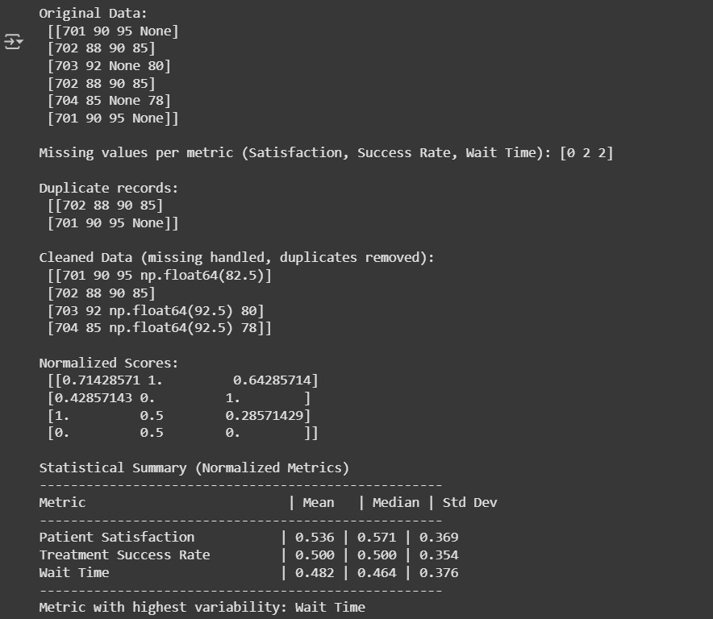

RESULT:
Thus, the Python program to analyze healthcare service efficiency using NumPy by cleaning data, normalizing metrics and performing statistical analysis to evaluate departmental performance has been executed successfully.

Ex.No. 3 (a) | COMPREHENSIVE STUDENT PERFORMANCE ANALYSIS
Date: | USING PANDAS
AIM:
To analyze student performance data using Pandas by handling missing marks, duplicate entries, inconsistent formatting, and by performing data transformation and statistical analysis.

ALGORITHM:
Step 1: Start.
Step 2: Load CSV into a DataFrame: df = pd.read_csv('student_scores.csv').
Step 3: Inspect data: df.info(), df.describe(), and df.isna().sum() to count missing values.
Step 4: Detect duplicates by name: df[df.duplicated(subset=['Name'], keep=False)].
Step 5: Remove duplicates, keeping first occurrence: df = df.drop_duplicates(subset=['Name'], keep='first').
Step 6: Replace missing marks with subject medians:
Step 7: Assign unique StudentID starting at 1: df.insert(0, 'StudentID', range(1, len(df)+1)).
Step 8: Add TotalMarks and AverageMarks:
Step 9: Min–Max normalize subject scores into new columns
Step 10: Compute normalized statistics and performance metric

SOURCE CODE:
import pandas as pd

df = pd.read_csv("student_scores.csv") print("Original Data:\n", df) print("\nDataset Info:") print(df.info()) print("\nDataset Description:\n", df.describe()) print("\nMissing Values per Subject:\n", df.isna().sum()) duplicates = df[df.duplicated(subset="Name")] print("\nDuplicate Rows:\n", duplicates)
df = df.drop_duplicates(subset="Name", keep="first").copy() for subject in ["Math", "Physics", "Chemistry"]: median_val = df[subject].median() df[subject] = df[subject].fillna(median_val) df.insert(0, "StudentID", range(1, len(df) + 1))

print("\nCleaned Data:\n", df) df["TotalMarks"] = df[["Math", "Physics", "Chemistry"]].sum(axis=1) df["AverageMarks"] = df["TotalMarks"] / 3 for subject in ["Math", "Physics", "Chemistry"]:
min_val = df[subject].min() max_val = df[subject].max() df[f"{subject}_Norm"] = (df[subject] - min_val) / (max_val - min_val) print("\nData with Normalized Scores:\n", df) stats = df[["Math_Norm", "Physics_Norm", "Chemistry_Norm"]].agg(["mean", "median",
"std"]) print("\nNormalized Score Statistics:\n", stats) most_variable_subject = stats.loc["std"].idxmax() print("\nSubject with highest variability:", most_variable_subject) top_students = df.nlargest(3, "AverageMarks")[["StudentID", "Name", "AverageMarks"]] print("\nTop 3 Students:\n", top_students) pivot_avg = df[["Math", "Physics", "Chemistry"]].mean().to_frame(name="Average Score") # Excluded 'Name' column print("\nSubject-wise Average Performance:\n", pivot_avg)

OUTPUT:

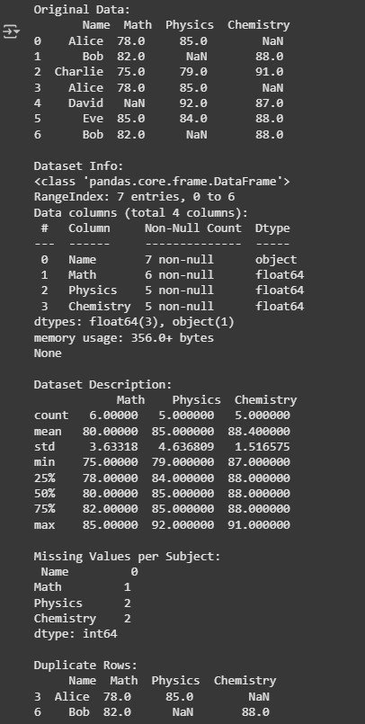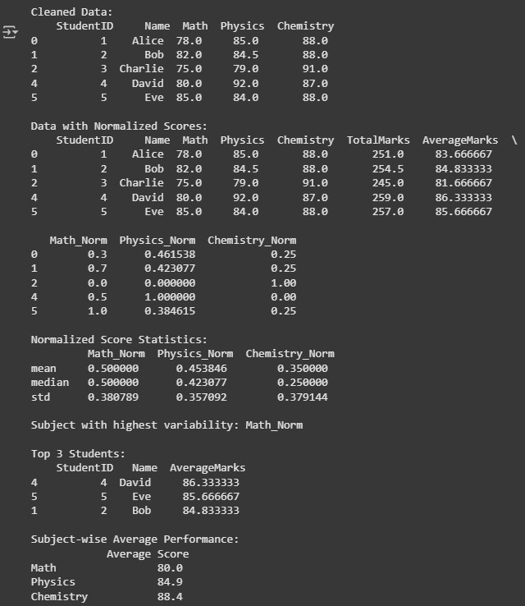

RESULT:
Thus, the Python program to clean, normalize and analyze student assessment scores using Pandas addressing missing marks, duplicates, formatting and producing key statistical and performance insights has been executed successfully.
Ex.No. 3 (b) | MOVIE RATINGS AGGREGATION AND REVIEW ANALYSIS
Date : | MOVIE RATINGS AGGREGATION AND REVIEW ANALYSIS

AIM:
To clean, aggregate and analyze movie ratings and reviews using Pandas addressing data duplication, missing values and text inconsistencies.
ALGORITHM:
Step 1: Start.
Step 2: Load the dataset movie_reviews.csv into a Pandas DataFrame. Step 3: Remove duplicate entries based on UserID and MovieTitle using drop_duplicates().
Step 4: Replace missing ratings with the average rating per movie using groupby().transform('mean').
Step 5: Clean review text by stripping whitespace and converting to lowercase using vectorized string methods (.str.strip(), .str.lower()).
Step 6: Group data by MovieTitle and compute mean, median, and count of ratings.
Step 7: Identify the top-rated movie using the highest mean rating. Step 8: Count occurrences of the word “amazing” in all reviews using .str.contains('amazing').
Step 9: Filter reviews where rating > 4.0 and review text contains “plot”.
Step 10: Display the cleaned dataset, aggregated statistics, and filtered insights. Step 11: Stop

SOURCE CODE:
import pandas as pd

df = pd.read_csv("/content/movie_reviews.csv")
df = df.drop_duplicates(subset=['UserID', 'MovieTitle'], keep='first')
df['Rating'] = df.groupby('MovieTitle')['Rating'].transform(lambda x: x.fillna(x.mean())) df['ReviewText'] = df['ReviewText'].str.strip().str.lower()
agg_stats = df.groupby('MovieTitle')['Rating'].agg(['mean', 'median', 'count']).reset_index() print("Movie Ratings Aggregation:\n", agg_stats)
top_movie = agg_stats.loc[agg_stats['mean'].idxmax(), 'MovieTitle'] print(f"\nTop-rated movie: {top_movie}")
# Count occurrences of the word "amazing" across all reviews amazing_count = df['ReviewText'].str.count(r'\bamazing\b').sum() print(f"\nTotal 'amazing' word count in reviews: {amazing_count}")
filtered_reviews = df[(df['Rating'] > 4.0) & (df['ReviewText'].str.contains(r'\bplot\b'))] print("\nFiltered reviews (rating > 4.0 and contains 'plot'):\n", filtered_reviews)

OUTPUT:

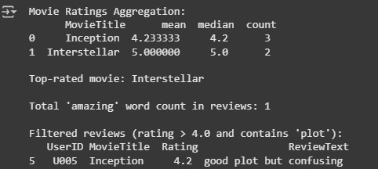

RESULT:
Thus, the Python program to analyze movie ratings and reviews using Pandas by removing duplicates, handling missing ratings, cleaning text data, performing aggregation and extracting keyword-based insights has been executed successfully.
Ex.No. 4 | VISUALIZING EMPLOYEE PRODUCTIVITY(LINE &  BAR CHART)
Date : | VISUALIZING EMPLOYEE PRODUCTIVITY(LINE &  BAR CHART)

AIM:
To visualize employee productivity trends across quarters and compare average productivity between departments using line and bar charts in Pandas and Matplotlib.
ALGORITHM:
Step 1: Start.
Step 2: Initialize or load the dataset containing employee productivity scores for each quarter.
Step 3: Convert the data into a Pandas DataFrame.
Step 4: Identify and remove duplicate employee records using .drop_duplicates().
Step 5: Handle missing values by replacing them with the mean or median of the respective quarter using .fillna().
Step 6: Plot a Line Chart to visualize productivity trends across quarters for all employees or departments.
Step 7: Group data by department and calculate the average productivity per department across all quarters.
Step 8: Plot a Bar Chart to compare average productivity among departments.
Step 9: Display and interpret the visualizations.
Step 10: Stop.

SOURCE CODE:
import pandas as pd import matplotlib.pyplot as plt

data = {
'Emp_ID':[201,202,203,204,205,206,202,207,208,209],
'Department':['IT','HR','IT','Sales','HR','IT','HR','Sales','Sales','IT'],
'Q1':[80,70,90,None,78,88,70,65,72,91],
'Q2':[85,None,95,65,82,84,None,70,75,87],
'Q3':[None,75,92,70,79,90,75,None,78,89], 'Q4':[90,80,94,75,85,86,80,68,None,93]} df = pd.DataFrame(data) df = df.drop_duplicates()
df = df.fillna(df.mean(numeric_only=True))
#Line Chart
df.groupby('Department')[['Q1','Q2','Q3','Q4']].mean().T.plot(marker='o') plt.title('Average Productivity Trend per Department') plt.xlabel('Quarter') plt.ylabel('Productivity') plt.show() #Bar Chart
df.groupby('Department')[['Q1','Q2','Q3','Q4']].mean().mean(axis=1).plot(kind='bar') plt.title('Average Productivity by Department') plt.ylabel('Productivity') plt.show()

OUTPUT:
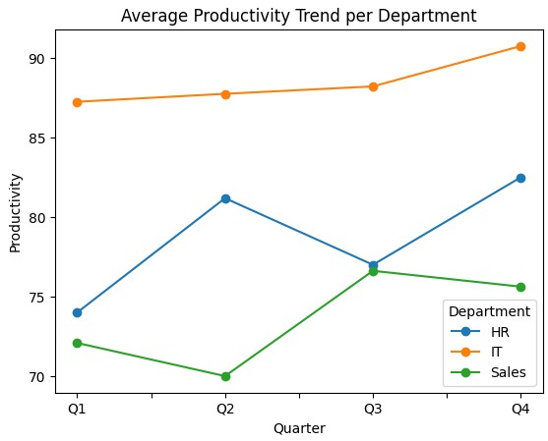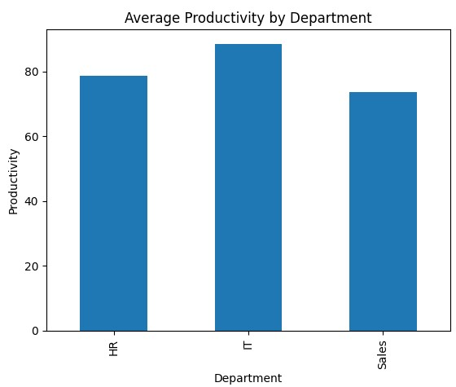

RESULT:
Thus, the Python program to visualize employee productivity trends and departmental averages using line and bar charts after cleaning and imputing missing data has been executed successfully.
Ex.No. 5 | VISUALIZING EMPLOYEE PRODUCTIVITY (BOX &  SCATTER PLOTS)
Date : | VISUALIZING EMPLOYEE PRODUCTIVITY (BOX &  SCATTER PLOTS)
AIM:
To analyze the distribution and relationships of employee productivity scores across quarters using box and scatter plots in Pandas and Matplotlib.
ALGORITHM:
Step 1: Start.
Step 2: Load the cleaned employee productivity dataset from the previous exercise.
Step 3: Verify the data integrity (no duplicates or missing values).
Step 4: Plot a Box Plot to analyze the distribution and variability of productivity scores across the four quarters (Q1–Q4).
Step 5: Plot a Scatter Plot to visualize the relationship between productivity in two quarters.
Step 6: Label all axes, add titles, and apply color differentiation for clarity.
Step 7: Interpret visual patterns to assess consistency and correlations in performance.
Step 8: Stop.

SOURCE CODE:
import pandas as pd import matplotlib.pyplot as plt

data = {
'Emp_ID':[201,202,203,204,205,206,202,207,208,209],
'Department':['IT','HR','IT','Sales','HR','IT','HR','Sales','Sales','IT'],
'Q1':[80,70,90,None,78,88,70,65,72,91],
'Q2':[85,None,95,65,82,84,None,70,75,87],
'Q3':[None,75,92,70,79,90,75,None,78,89],
'Q4':[90,80,94,75,85,86,80,68,None,93]
} df = pd.DataFrame(data) df = df.drop_duplicates() df = df.fillna(df.mean(numeric_only=True)) #Box plot df[['Q1','Q2','Q3','Q4']].plot(kind='box') plt.title('Productivity Distribution per Quarter') plt.ylabel('Scores') plt.show() # Scatter Plot plt.scatter(df['Q1'], df['Q2']) plt.title('Q1 vs Q2 Productivity Relationship') plt.xlabel('Q1') plt.ylabel('Q2') plt.show()

OUTPUT:

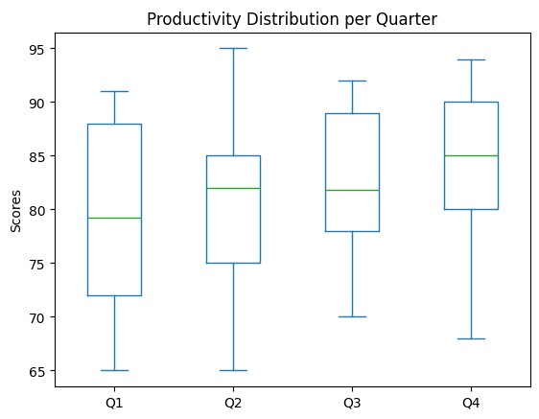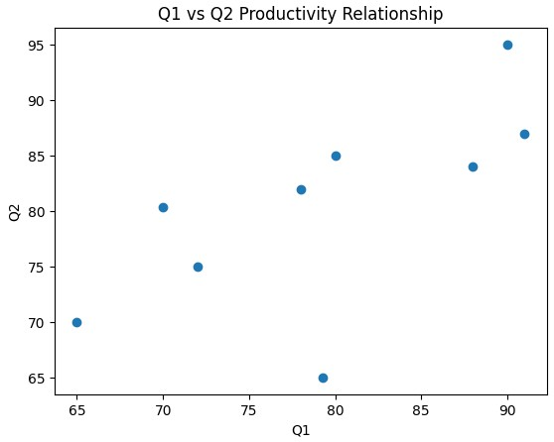

RESULT:
Thus, the Python program to analyze employee productivity distribution and inter-quarter relationships using box and scatter plots providing insights into performance variability and consistency has been executed successfully.

Ex.No. 6 | SALES PERFORMANCE VISUALIZATION USING  STORE NAMES
Date : | SALES PERFORMANCE VISUALIZATION USING  STORE NAMES
AIM:
To visualize and analyze monthly sales trends across different retail stores by cleaning data, handling missing values and generating graphical insights using area charts, heatmaps and correlograms.
ALGORITHM:
Step 1: Start.
Step 2: Import the necessary libraries pandas, numpy, matplotlib, and seaborn.
Step 3: Initialize or load the dataset containing monthly sales for each store.
Step 4: Identify and remove duplicate records using .drop_duplicates().
Step 5: Handle missing values by replacing them with the mean or median of respective months using .fillna().
Step 6: Plot an Area Chart to visualize sales trends of all stores over the months (Jan–Apr).
Step 7: Compute the correlation matrix among monthly sales using .corr().
Step 8: Visualize the correlation matrix using a Heatmap to highlight strong and weak relationships between months.
Step 9: Create a Correlogram using seaborn.pairplot() to explore pairwise relationships among monthly sales figures.
Step 10: Analyze and interpret the visualizations to identify patterns and inter-month dependencies.
Step 11: Stop.

SOURCE CODE:

import pandas as pd import matplotlib.pyplot as plt import seaborn as sns

data = {
'Store': ['Store_A','Store_B','Store_C','Store_D','Store_E',
'Store_B','Store_A','Store_C','Store_D','Store_E'],
'Jan': [15000,12000,14000,13500,None,12000,15000,None,13500,11500],
'Feb': [18000,12500,13800,None,11000,12500,18000,13800,13400,None],
'Mar': [None,13000,14200,13700,12000,13000,None,14200,13700,12000],
'Apr': [17000,None,14500,13900,11800,None,17000,14500,None,11800]
}
df = pd.DataFrame(data) df = df.drop_duplicates()
df = df.fillna(df.mean(numeric_only=True))
df_group = df.groupby('Store')[['Jan','Feb','Mar','Apr']].mean() df_group.T.plot.area(figsize=(8,5)) plt.title('Monthly Sales Trend by Store') plt.xlabel('Month'); plt.ylabel('Sales ($)') plt.show() plt.figure(figsize=(6,4))
sns.heatmap(df_group, annot=True, fmt=".0f", cmap="YlGnBu") plt.title('Sales Heatmap (Stores vs Months)') plt.show() plt.figure(figsize=(5,4))
sns.heatmap(df_group.corr(), annot=True, cmap="coolwarm") plt.title('Sales Correlation Between Months') plt.show()

OUTPUT:
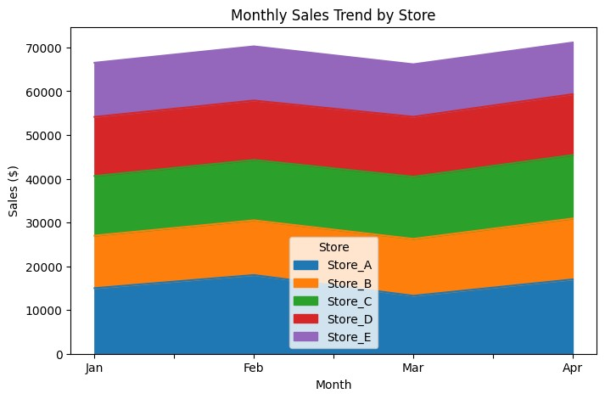

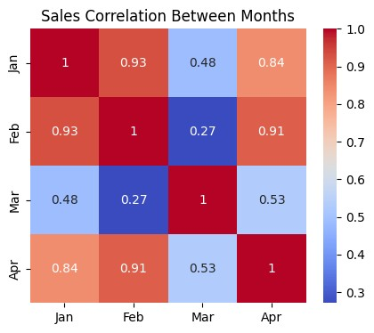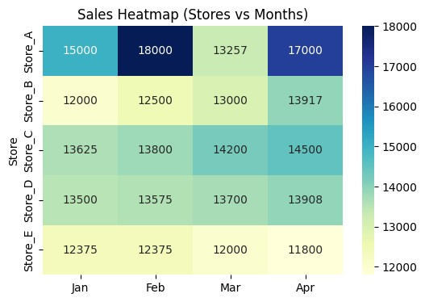

RESULT:
Thus, the Python program to visualize and analyze monthly store sales performance using Pandas, Matplotlib and Seaborn through area charts, heatmaps and correlograms has been executed successfully.

Ex.No. 7 | VISUALIZING TEXT DATA USING WORD CLOUD
Date : | VISUALIZING TEXT DATA USING WORD CLOUD
AIM:
To analyze and visualize audience sentiment from a synthetic dataset of movie reviews by generating word clouds for positive and negative sentiments, providing insights into commonly used expressions.
ALGORITHM:
Step 1: Start.
Step 2: Import the necessary libraries pandas, matplotlib and wordcloud.
Step 3: Load the movie review dataset into a Pandas DataFrame.
Step 4: Separate the dataset into positive and negative reviews based on the sentiment label (1 = Positive, 0 = Negative).
Step 5: Preprocess the text data by converting all text to lowercase also removing punctuation, numbers and stopwords.
Step 6: Generate a Word Cloud for All reviews combined, only positive reviews and only negative reviews.
Step 7: Visualize and display the word clouds using matplotlib.pyplot.
Step 8: Interpret the frequently used words in positive and negative reviews to understand sentiment trends.
Step 9: Stop.

SOURCE CODE:
import pandas as pd from wordcloud import WordCloud import matplotlib.pyplot as plt import string from nltk.corpus import stopwords import nltk nltk.download('stopwords') data = {
'Review': [
"The movie was absolutely fantastic with brilliant acting",
"A dull storyline made the film boring and predictable",
"Loved the visuals and the music score",
"The film was a complete waste of time",
"An excellent performance by the lead actor",
"Poor script and weak direction ruined the experience",
"A fun, heartwarming movie for the entire family",
"Disappointing and far too slow in the middle",
"Great balance of humor and emotion throughout",
"The dialogue felt forced and unnatural",
"A refreshing story with strong character development",
"The ending was confusing and unsatisfying",
"Brilliant direction and flawless screenplay",
"Weak plot twists and badly written characters",
"The cinematography was stunning and breathtaking",
"An overhyped movie with little substance",
"Perfect blend of action, drama, and comedy",
"The pacing was uneven and dragged in parts",
"A powerful message delivered beautifully",
"Forgettable acting and lack of originality",
"Heartfelt performances made the film inspiring",
"Too many clichés ruined the experience",
"An emotional rollercoaster that touched the audience",
"The sound design was poor and distracting",
"Wonderful direction and meaningful storytelling",
"The background score was irritating and loud",
"Beautifully crafted movie with a touching theme",
"Predictable plot that offered no surprises"
], 'Label': [1,0,1,0,1,0,1,0,1,0,1,0,1,0,1,0,1,0,1,0,1,0,1,0,1,0,1,0,1,0]} df = pd.DataFrame(data) stop_words = set(stopwords.words('english')) def clean_text(text): text = text.lower() text = ''.join([c for c in text if c not in string.punctuation]) words = [w for w in text.split() if w not in stop_words] return ' '.join(words)
df['Cleaned'] = df['Review'].apply(clean_text) positive_reviews = ' '.join(df[df['Label']==1]['Cleaned']) negative_reviews = ' '.join(df[df['Label']==0]['Cleaned']) all_reviews = ' '.join(df['Cleaned']) plt.figure(figsize=(15,8)) plt.subplot(1,3,1) wc_all = WordCloud(width=400, height=300, background_color='white', colormap='viridis').generate(all_reviews) plt.imshow(wc_all); plt.axis('off'); plt.title('All Reviews', fontsize=14) plt.subplot(1,3,2) wc_pos = WordCloud(width=400, height=300, background_color='white', colormap='Greens').generate(positive_reviews) plt.imshow(wc_pos); plt.axis('off'); plt.title('Positive Reviews', fontsize=14) plt.subplot(1,3,3) wc_neg = WordCloud(width=400, height=300, background_color='white', colormap='Reds').generate(negative_reviews) plt.imshow(wc_neg); plt.axis('off'); plt.title('Negative Reviews', fontsize=14) plt.tight_layout() plt.show()

OUTPUT :



RESULT:
Thus, the Python program to analyze and visualize movie review sentiments using word clouds by cleaning text data and displaying frequently used positive and negative expressions has been executed successfully.

Ex.No. 8 | IMPLEMENTATION OF LINEAR REGRESSION
Date : | IMPLEMENTATION OF LINEAR REGRESSION
AIM:
To analyze the relationship between TV advertising budget and sales revenue using both the Mathematical Least Squares Method and the Scikit-learn Linear Regression Model and to evaluate the model’s performance using R².
ALGORITHM:
Step 1: Start.
Step 2: Load the dataset containing TV advertising budgets and corresponding sales values.
Step 3: Compute the mean values of TV and Sales.
Step 4: Calculate the slope (b₁) and intercept (b₀) using the Least Squares formulas, and form the regression equation ŷ = b₀ + b₁x.
Step 5: Predict sales and calculate the R² value to measure model accuracy.
Step 6: Implement the Scikit-learn LinearRegression model and fit it to the same data.
Step 7: Retrieve and compare slope, intercept, and R² score from both methods for validation.
Step 8: Visualize the relationship using a scatter plot with the regression line.
Step 9: Stop.

SOURCE CODE:
import numpy as np import pandas as pd import matplotlib.pyplot as plt
from sklearn.linear_model import LinearRegression from sklearn.metrics import r2_score

data = { 'TV': [230.1, 44.5, 17.2, 151.5, 180.8, 8.7, 57.5, 120.2, 220.3, 75.5],
'Sales': [22.1, 10.4, 9.3, 18.5, 20.1, 4.8, 11.8, 17.0, 21.4, 12.0]} df = pd.DataFrame(data) x_mean = np.mean(df['TV']) y_mean = np.mean(df['Sales'])
b1 = np.sum((df['TV'] - x_mean) * (df['Sales'] - y_mean)) / np.sum((df['TV'] - x_mean)**2) b0 = y_mean - b1 * x_mean
print("----- Mathematical Regression -----") print(f"Slope (b1): {b1:.4f}") print(f"Intercept (b0): {b0:.4f}") df['Pred_Sales_Math'] = b0 + b1 * df['TV'] ss_total = np.sum((df['Sales'] - y_mean)**2) ss_res = np.sum((df['Sales'] - df['Pred_Sales_Math'])**2) r2_math = 1 - (ss_res / ss_total) print(f"R² (Mathematical): {r2_math:.4f}")
plt.scatter(df['TV'], df['Sales'], color='blue', label='Actual Data') plt.plot(df['TV'], df['Pred_Sales_Math'], color='red', label='Regression Line') plt.title('TV Advertising vs Sales (Manual Least Squares)') plt.xlabel('TV Advertising Budget (in $1000)') plt.ylabel('Sales (in 1000 units)') plt.legend() plt.show() X = df[['TV']] y = df['Sales'] model = LinearRegression() model.fit(X, y) y_pred = model.predict(X)
print("\n----- Scikit-learn Regression -----") print(f"Slope (Coefficient): {model.coef_[0]:.4f}") print(f"Intercept: {model.intercept_:.4f}") print(f"R² (Scikit-learn): {model.score(X, y):.4f}") comparison = pd.DataFrame({
'Method': ['Mathematical', 'Scikit-learn'],
'Slope': [b1, model.coef_[0]],
'Intercept': [b0, model.intercept_], 'R²': [r2_math, model.score(X, y)] })
print("\nComparison Summary:") print(comparison.round(4))

OUTPUT:
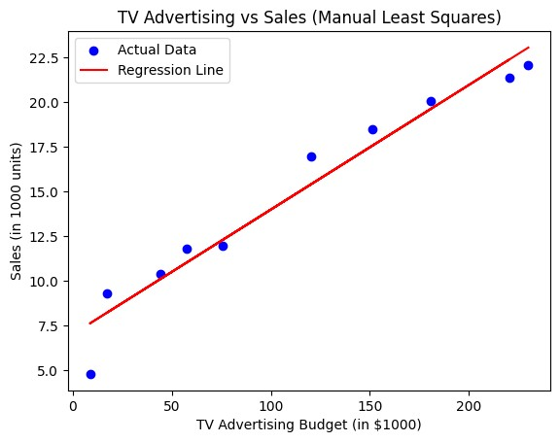

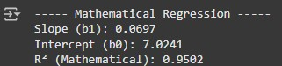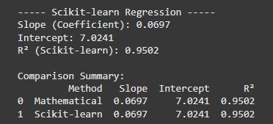

RESULT:
Thus, the Python program to analyze the relationship between TV advertising and product sales using both the Mathematical Least Squares Method and the Scikit-learn Linear Regression Model has been executed successfully.

Ex.No. 9 | IMPLEMENTATION OF LOGISTIC REGRESSION
Date : | IMPLEMENTATION OF LOGISTIC REGRESSION
AIM:
To build & evaluate Logistic Regression model that predicts the likelihood of diabetes in patients using key medical features such as glucose level, BMI, blood pressure, insulin level and age.
ALGORITHM:
Step 1: Start.
Step 2: Load the Diabetes Dataset and inspect its structure using Pandas.
Step 3: Preprocess the data by handling missing or invalid values and ensuring all features are numerical.
Step 4: Separate the dataset into features (X) and target (y) (Outcome column).
Step 5: Split the data into training and testing sets using train_test_split().
Step 6: Initialize and train a LogisticRegression model using the training data.
Step 7: Predict diabetes outcomes for the test set and evaluate model performance using Accuracy, F1-Score, and Confusion Matrix.
Step 8: Visualize the confusion matrix and interpret the model’s predictive capability.
Step 9: Stop.

SOURCE CODE:

import pandas as pd import numpy as np
from sklearn.model_selection import train_test_split from sklearn.linear_model import LogisticRegression
from sklearn.metrics import accuracy_score, f1_score, confusion_matrix, classification_report import seaborn as sns import matplotlib.pyplot as plt

df = pd.read_csv("/content/diabetes (1).csv") # Ensure your dataset file is in the same folder print("Dataset Preview:") print(df.head(), "\n") print("Dataset Information:") print(df.info(), "\n")
print("Missing Values in Each Column:") print(df.isnull().sum(), "\n")
cols_with_invalid_zeros = ['Glucose', 'BloodPressure', 'Insulin', 'BMI'] df[cols_with_invalid_zeros] = df[cols_with_invalid_zeros].replace(0, np.nan) df = df.fillna(df.mean(numeric_only=True))
X = df[['Glucose', 'BMI', 'BloodPressure', 'Age', 'Insulin']] y = df['Outcome']
X_train, X_test, y_train, y_test = train_test_split(X, y, test_size=0.2, random_state=42) model = LogisticRegression(max_iter=1000) model.fit(X_train, y_train) y_pred = model.predict(X_test) accuracy = accuracy_score(y_test, y_pred) f1 = f1_score(y_test, y_pred) cm = confusion_matrix(y_test, y_pred) print("----- Model Evaluation -----") print(f"Accuracy Score: {accuracy:.4f}") print(f"F1-Score: {f1:.4f}")
print("\nClassification Report:\n", classification_report(y_test, y_pred)) plt.figure(figsize=(5,4))
sns.heatmap(cm, annot=True, fmt='d', cmap='Blues', xticklabels=['Non-Diabetic', 'Diabetic'], yticklabels=['Non-Diabetic', 'Diabetic']) plt.title('Confusion Matrix - Diabetes Prediction') plt.xlabel('Predicted') plt.ylabel('Actual') plt.show()
new_patient = pd.DataFrame([{
'Glucose': 145,
'BMI': 32.5,
'BloodPressure': 82,
'Age': 45,
'Insulin': 130
}])
prediction = model.predict(new_patient)
print(f"\nPredicted Outcome for New Patient: {'Diabetic' if prediction[0]==1 else 'Non-Diabetic'}")

OUTPUT:

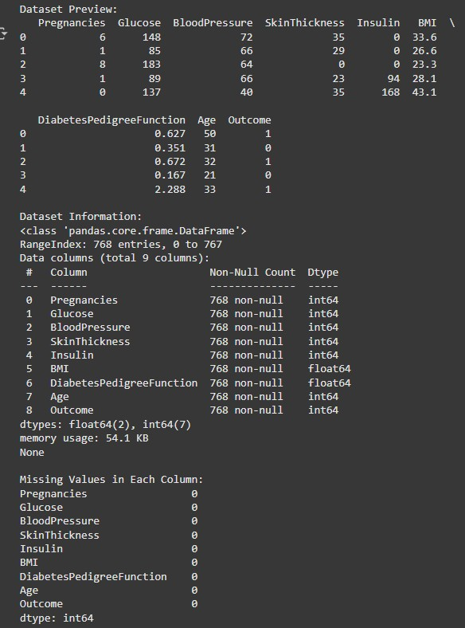
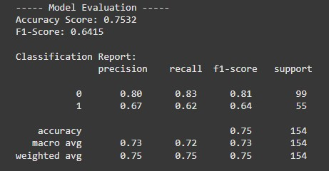

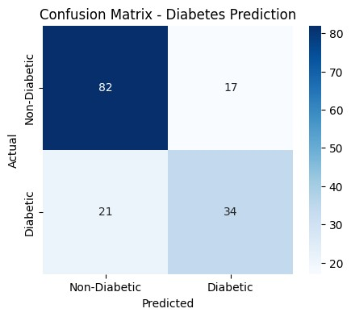

RESULT:
Thus, the Python program to predict diabetes occurrence using the Logistic Regression model has been executed successfully.
Ex.No. 10 | IMPLEMENTATION OF SVM CLASSIFICATION  TECHNIQUES
Date : | IMPLEMENTATION OF SVM CLASSIFICATION  TECHNIQUES
AIM:
To implement and evaluate a Support Vector Machine (SVM) classifier for early detection of breast cancer using the Breast Cancer Wisconsin Dataset.
ALGORITHM:
Step 1: Start.
Step 2: Load the Breast Cancer Wisconsin Dataset from scikit-learn.
Step 3: Inspect the dataset to understand features and target labels (benign or malignant).
Step 4: Split the dataset into training and testing sets using train_test_split().
Step 5: Initialize an SVM classifier (e.g., SVC(kernel='linear')).
Step 6: Train the model on the training dataset using .fit(X_train, y_train).
Step 7: Predict cancer outcomes on the test set and compute the accuracy score using .score() or accuracy_score().
Step 8: Display the classification accuracy and interpret the model’s effectiveness.
Step 9: Stop.

SOURCE CODE:

import pandas as pd
from sklearn.datasets import load_breast_cancer from sklearn.model_selection import train_test_split from sklearn.svm import SVC
from sklearn.metrics import accuracy_score, classification_report, confusion_matrix import seaborn as sns import matplotlib.pyplot as plt

data = load_breast_cancer()
X = pd.DataFrame(data.data, columns=data.feature_names) y = pd.Series(data.target)
print("Dataset Preview:") print(X.head())
print("\nTarget Distribution:") print(y.value_counts())
X_train, X_test, y_train, y_test = train_test_split(X, y, test_size=0.2,random_state=42,stratify=y) svm_model = SVC(kernel='linear', random_state=42) svm_model.fit(X_train, y_train) y_pred = svm_model.predict(X_test) accuracy = accuracy_score(y_test, y_pred) print(f"\nSVM Classifier Accuracy: {accuracy:.4f}\n")
print("Classification Report:\n", classification_report(y_test, y_pred)) cm = confusion_matrix(y_test, y_pred) plt.figure(figsize=(6,5))
sns.heatmap(cm, annot=True, fmt='d', cmap='Blues', xticklabels=['Malignant','Benign'], yticklabels=['Malignant','Benign']) plt.title('Confusion Matrix - Breast Cancer SVM') plt.xlabel('Predicted') plt.ylabel('Actual') plt.show()

OUTPUT:
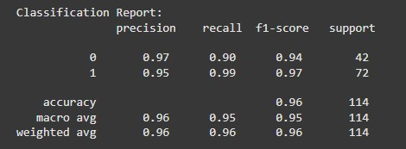
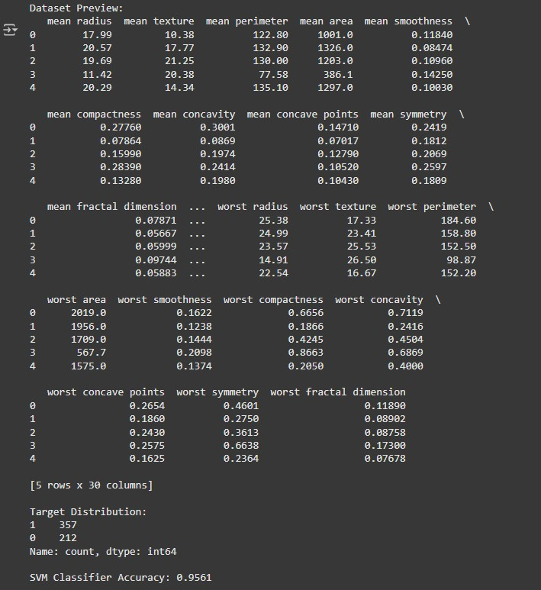
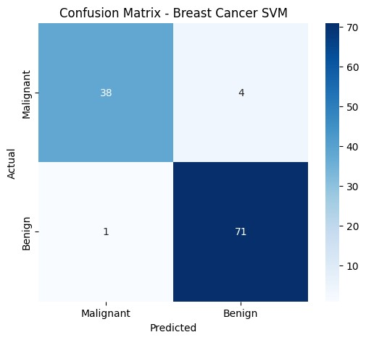

RESULT:
Thus, the Python program to classify breast cancer cases using the Support Vector Machine (SVM) algorithm has been executed successfully.

Ex.No. 11 | IMPLEMENTATION OF DECISION TREE  CLASSIFICATION TECHNIQUES
Date : | IMPLEMENTATION OF DECISION TREE  CLASSIFICATION TECHNIQUES
AIM:
To build and evaluate a Decision Tree classifier using the Breast Cancer Wisconsin dataset that classifies tumors as benign or malignant and to visualize the trained tree for interpretability.
ALGORITHM:
Step 1: Start.
Step 2: Load the Breast Cancer Wisconsin dataset (from sklearn.datasets) and inspect features and target labels.
Step 3: Split the data into training and testing sets using train_test_split().
Step 4: Initialize a DecisionTreeClassifier (optionally set max_depth, criterion, and random_state).
Step 5: Train the classifier with .fit(X_train, y_train).
Step 6: Predict labels for the test set and compute accuracy using accuracy_score() (or .score()). Step 7: Visualize the trained decision tree using plot_tree() or export_graphviz() (with feature names and class names), and display the plotted tree diagram.
Step 8: Display accuracy, interpret key splits in the plotted tree.
Step 9: Stop.

SOURCE CODE:

import pandas as pd
from sklearn.datasets import load_breast_cancer from sklearn.model_selection import train_test_split from sklearn.tree import DecisionTreeClassifier, plot_tree from sklearn.metrics import accuracy_score, classification_report import matplotlib.pyplot as plt

data = load_breast_cancer()
X = pd.DataFrame(data.data, columns=data.feature_names) y = pd.Series(data.target) # 0 = malignant, 1 = benign print("Dataset Preview:") print(X.head())
print("\nTarget Distribution:") print(y.value_counts())
X_train, X_test, y_train, y_test = train_test_split(X, y,test_size=0.2,random_state=42, stratify=y) dt_model = DecisionTreeClassifier(random_state=42) dt_model.fit(X_train, y_train) y_pred = dt_model.predict(X_test) accuracy = accuracy_score(y_test, y_pred) print(f"\nDecision Tree Accuracy: {accuracy:.4f}")
print("\nClassification Report:\n", classification_report(y_test, y_pred)) plt.figure(figsize=(20,10)) plot_tree( dt_model,
feature_names=data.feature_names, class_names=data.target_names, filled=True, rounded=True, fontsize=10
)
plt.title("Decision Tree - Breast Cancer Classification") plt.show()

OUTPUT;
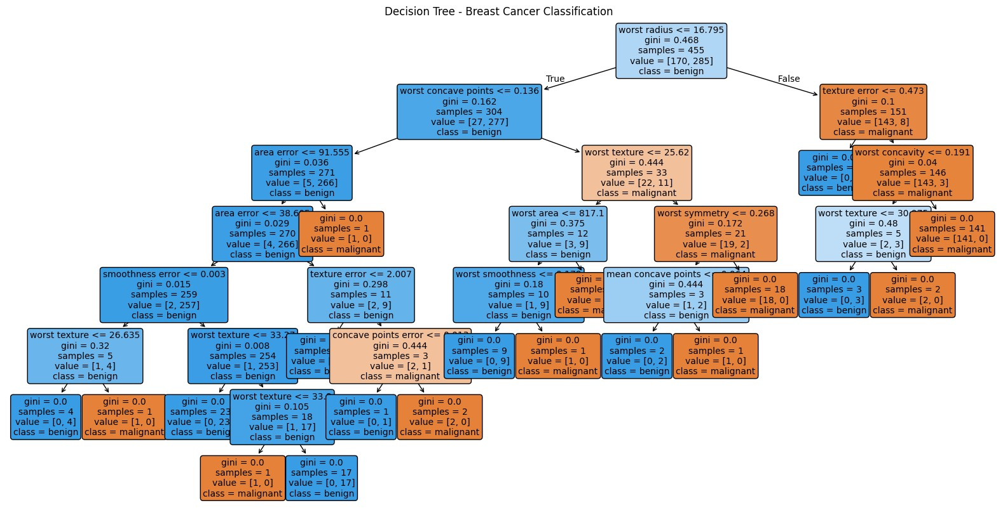
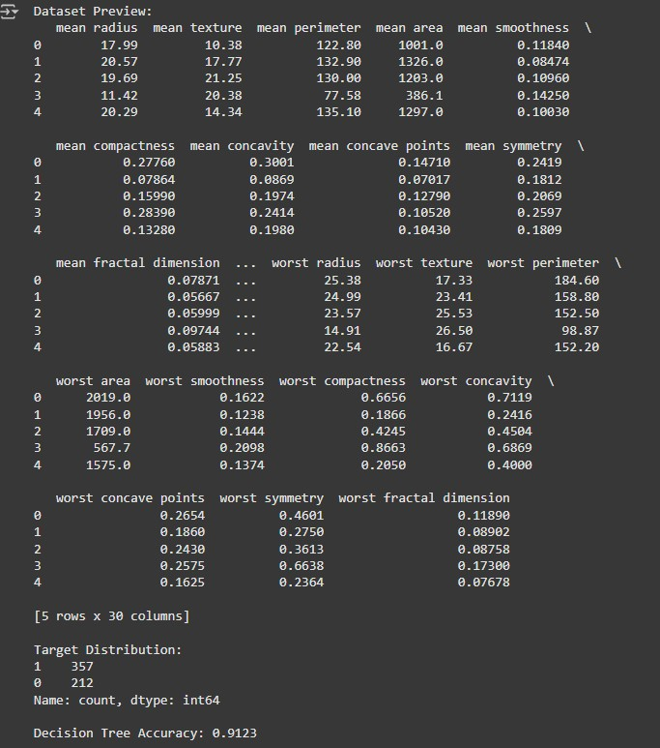

RESULT:
Thus, the Python program to classify tumors using a Decision Tree classifier has been executed successfully.
Ex.No. 12 | IMPLEMENTATION OF HIERARCHICAL  CLUSTERING
Date : | IMPLEMENTATION OF HIERARCHICAL  CLUSTERING
AIM:
To perform Hierarchical Clustering on customer data to identify distinct customer segments based on annual income and spending score, aiding in targeted marketing strategies.
ALGORITHM:
Step 1: Start.
Step 2: Import required libraries – numpy, pandas, matplotlib.pyplot, scipy.cluster.hierarchy, and sklearn.cluster.
Step 3: Load the customer dataset into a Pandas DataFrame and inspect the data.
Step 4: Select relevant features — Annual Income and Spending Score — and store them as variable X.
Step 5: Construct a dendrogram using scipy.cluster.hierarchy.linkage(X, method='ward') and plot it to determine the optimal number of clusters.
Step 6: Apply Agglomerative Clustering with the chosen number of clusters (e.g., 5) using AgglomerativeClustering(n_clusters=5, linkage='ward').
Step 7: Fit the model on X, obtain cluster labels, and assign them to the dataset.
Step 8: Visualize the resulting clusters on a scatter plot, differentiating each cluster by color and labeling axes for clarity.
Step 9: Stop.

SOURCE CODE:
import pandas as pd import numpy as np import matplotlib.pyplot as plt from scipy.cluster.hierarchy import linkage, dendrogram from sklearn.cluster import AgglomerativeClustering import seaborn as sns df = pd.read_csv("/content/Mall_Customers.csv") print("Dataset Preview:")

n_clusters = 5 hc = AgglomerativeClustering(n_clusters=n_clusters, metric='euclidean', linkage='ward') y_hc = hc.fit_predict(X) plt.figure(figsize=(12, 8)) print(df.head())
X = df[['Annual Income (k$)', 'Spending Score (1-100)']].values linked = linkage(X, method='ward') plt.figure(figsize=(12, 6)) dendrogram(linked, orientation='top', distance_sort='descending', show_leaf_counts=False, color_threshold=0) plt.title('Dendrogram - Hierarchical Clustering', fontsize=16) plt.xlabel('Customers', fontsize=12) plt.ylabel('Euclidean Distance', fontsize=12) plt.grid(True, linestyle='--', alpha=0.5) plt.show() palette = sns.color_palette("bright", n_clusters) markers = ['o', 's', 'D', '^', 'v'] for i in range(n_clusters):
plt.scatter(X[y_hc == i, 0], X[y_hc == i, 1], s=100, c=[palette[i]], marker=markers[i], edgecolor='k', alpha=0.7, label=f'Cluster {i+1}')

plt.title('Customer Segments - Hierarchical Clustering', fontsize=16) plt.xlabel('Annual Income (k$)', fontsize=12) plt.ylabel('Spending Score (1-100)', fontsize=12) plt.legend(title='Clusters', fontsize=10) plt.grid(True, linestyle='--', alpha=0.5) plt.show()

OUTPUT:
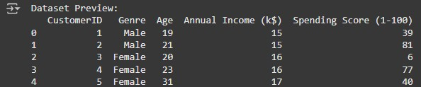
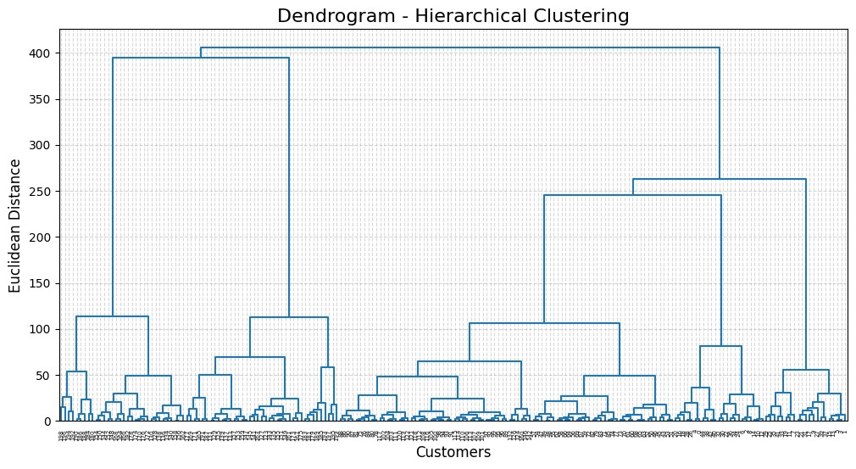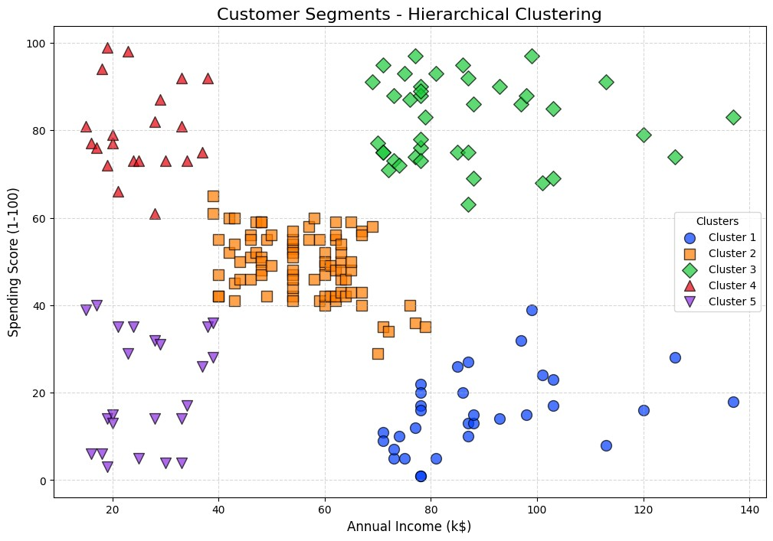
RESULT:
Thus, the Python program for performing Hierarchical Clustering on the retail store’s customer dataset has been executed successfully.
Ex.No. 13 | IMPLEMENTATION OF CLUSTERING TECHNIQUES  K MEANS
Date : | IMPLEMENTATION OF CLUSTERING TECHNIQUES  K MEANS
AIM:
To apply the K-Means Clustering algorithm to segment retail mall customers based on their annual income and spending score, enabling data-driven marketing and promotional strategies.
ALGORITHM:
Step 1: Start.
Step 2: Import necessary libraries numpy, pandas matplotlib.pyplot and sklearn.cluster.KMeans. Step 3: Load the dataset into a Pandas DataFrame and display the first few records for verification.
Step 4: Select the features Annual Income and Spending Score and store them in variable X. Step 5: Use the Elbow Method by plotting the within-cluster sum of squares (WCSS) against various K values to determine the optimal number of clusters.
Step 6: Initialize and apply the K-Means algorithm with the optimal K value (e.g., K=5), then fit and predict cluster labels for all customers.
Step 7: Visualize the resulting clusters using a scatter plot with different colors for each cluster and mark centroids with distinct markers.
Step 8: Interpret and label clusters to derive business insights.
Step 9: Stop.

SOURCE CODE:
import pandas as pd import matplotlib.pyplot as plt import seaborn as sns
from sklearn.cluster import KMeans df = pd.read_csv('/content/Mall_Customers.csv')
X = df[['Annual Income (k$)', 'Spending Score (1-100)']].values print("## 1. First Few Rows of the Dataset") print(df.head())
print("\n" + "="*50 + "\n") wcss = [] for i in range(1, 11):
kmeans = KMeans(n_clusters=i, init='k-means++', random_state=42, n_init=10) kmeans.fit(X)
wcss.append(kmeans.inertia_)
print("## 2. Generating Elbow Method Plot...") plt.figure(figsize=(10, 6))
plt.plot(range(1, 11), wcss, marker='o', linestyle='--') plt.title('Elbow Method') plt.xlabel('Number of Clusters (K)') plt.ylabel('WCSS (Inertia)') plt.show() optimal_k = 5
kmeans = KMeans(n_clusters=optimal_k, init='k-means++', random_state=42, n_init=10) y_kmeans = kmeans.fit_predict(X)
print("3. Cluster Assignments for Each Data Point") df['Cluster'] = y_kmeans print(df.head(10)) print("\n" + "="*50 + "\n") plt.figure(figsize=(12, 8)) cluster_map = {
0: {'label': 'Standard', 'color': 'green'},
1: {'label': 'Target', 'color': 'red'},
2: {'label': 'Sensible', 'color': 'orange'},
3: {'label': 'Careless', 'color': 'purple'},
4: {'label': 'Careful', 'color': 'blue'}
} for i in range(optimal_k): plt.scatter(X[y_kmeans == i, 0], X[y_kmeans == i, 1], s=100, c=cluster_map[i]['color'], label=cluster_map[i]['label'])
#centroid
plt.scatter(kmeans.cluster_centers_[:, 0], kmeans.cluster_centers_[:, 1], s=300, c='yellow', marker='*', label='Centroids', edgecolors='black') plt.title('Clusters of Customers') plt.xlabel('Annual Income (k$)') plt.ylabel('Spending Score (1-100)') plt.legend() plt.show()

OUTPUT:

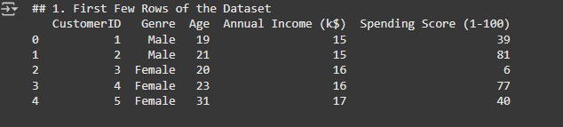
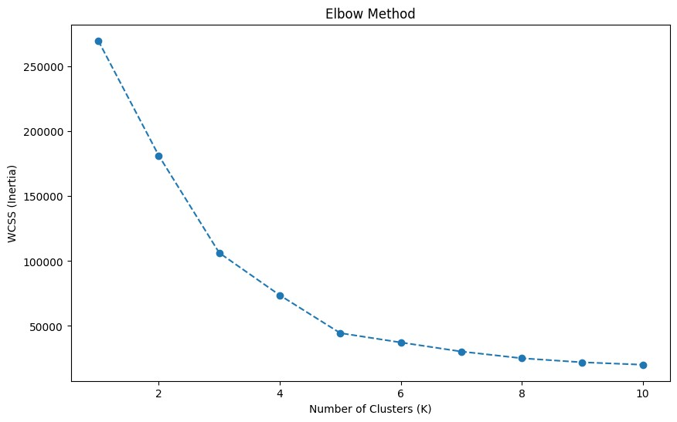
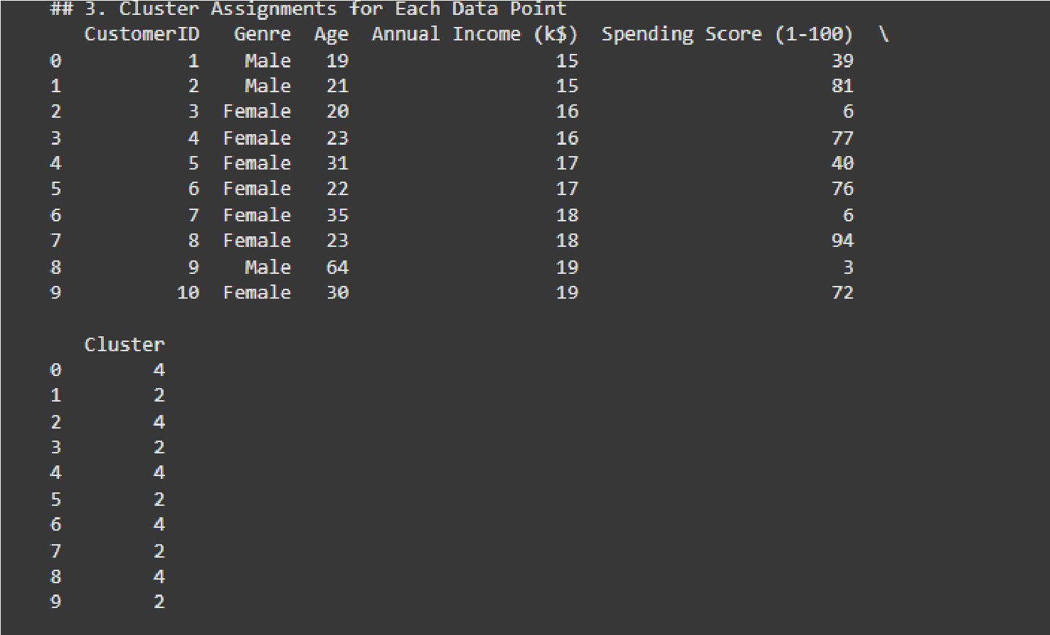

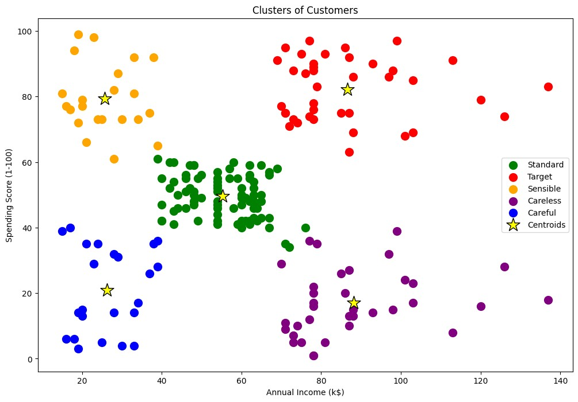

RESULT:
Thus, the Python program for K-Means Clustering has been executed successfully.

